**BANKING SYSTEM_UTILITY** -by Anushi Chauhan

**Table of Contents**

1. Introduction
   1. Features
   2. SWOT Analysis
   3. 4W’s and 1-H
2. Requirements
   1. High Level Requirements
   2. Low Level Requirements
3. Architecture
   1. Behavioral Diagram
      1. High Level
      2. Low Level
   2. Structural Diagram  
      3.2.1 High Level

3.2.2 Low Level

1. Test Plan
   1. High Level
   2. Low Level

**INTRODUCTION**

This is a simple utility project with basic banking system functionality like creating a new account, depositing and withdrawing money, transactions between different accounts.

* 1. **Features**

This Banking System provides facilities such as

* Opening and closing of an Account.
* Balance Enquiry.
* Deposit and withdrawl of money.
  1. **SWOT Analysis**

Strengths: User can Deposit, Withdraw, View balance.

Weaknesses: If account number and password is wrong no further actions can take place.

Opportunities: User can open an account. User can deposit and withdraw money.

Threats: If account number and password is wrong no further actions can take place.

* 1. 4W’s and 1-H

Who: Anyone who want to take the benefit of the facilities provided by the system can use it.

What: It covers the important baking facilities in one system.

When: Can be used whenever the user want to use the facilities available.

Where: Can be used using any C compiler.

How: It is implemented using C language.

**REQUIREMENTS**

**2.1 High Level Requirements**

|  |  |
| --- | --- |
| ID | High Level Requirement |
| HLR1 | User is able to open an account |
| HLR2 | User is able to deposit money |
| HLR3 | User is able to withdraw money |

**2.2 Low Level Requirements**

|  |  |
| --- | --- |
| ID | Low Level Requirement |
| LLR1 | User is able to see account details |
| LLR2 | User is able to see balance available |

**ARCHITECTURE**

**3.1 Behavioral Diagrams**

**3.1.1 High Level**

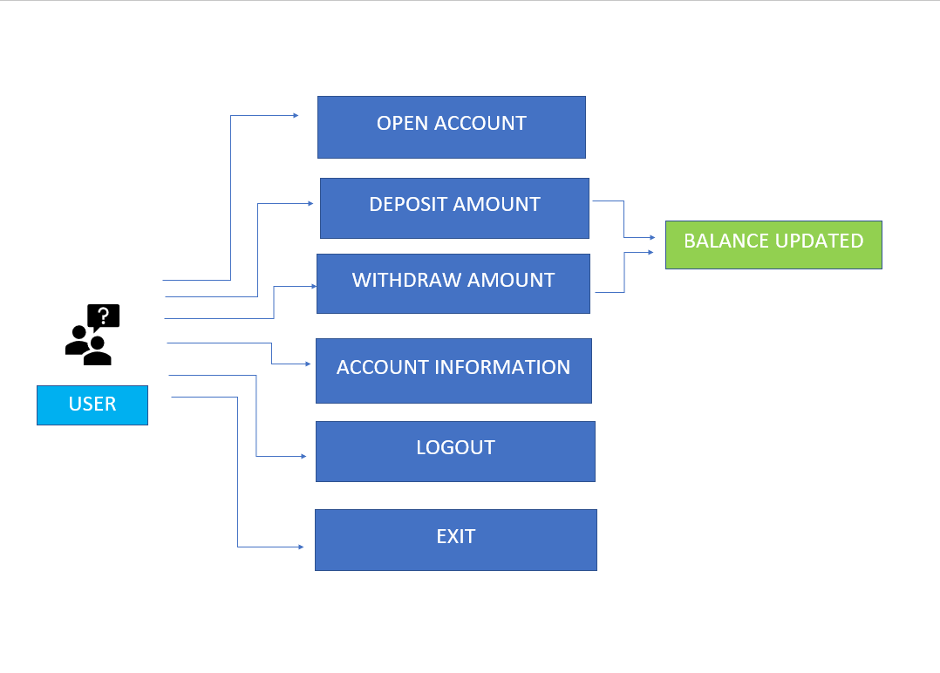

**3.1.2 Low Level**

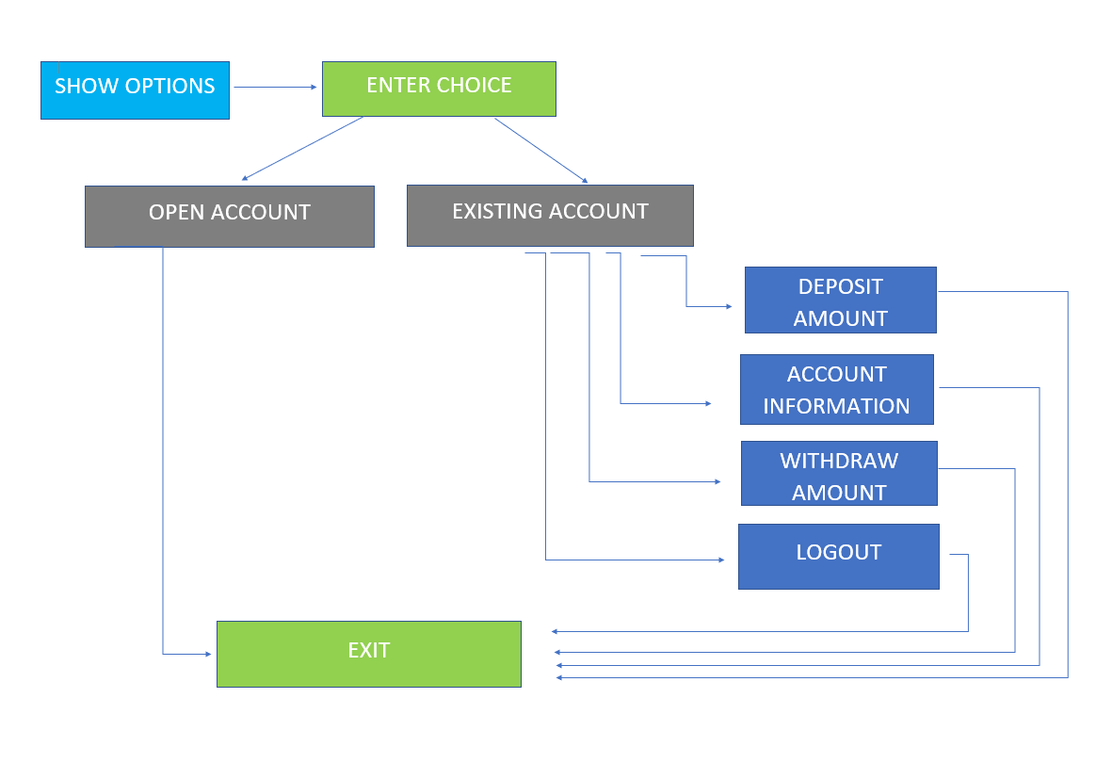

**3.1 Structural Diagrams**

**3.1.1 High Level**

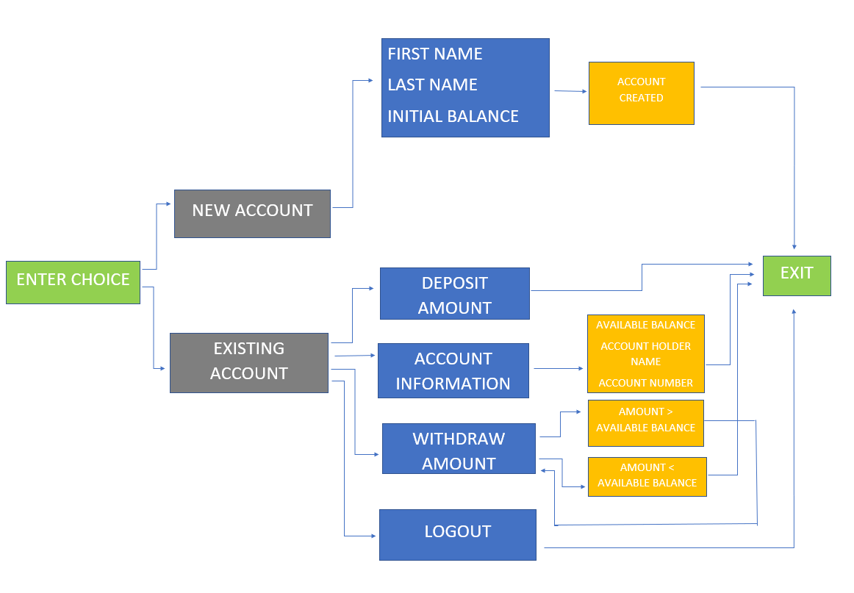

**3.1.2 Low Level**

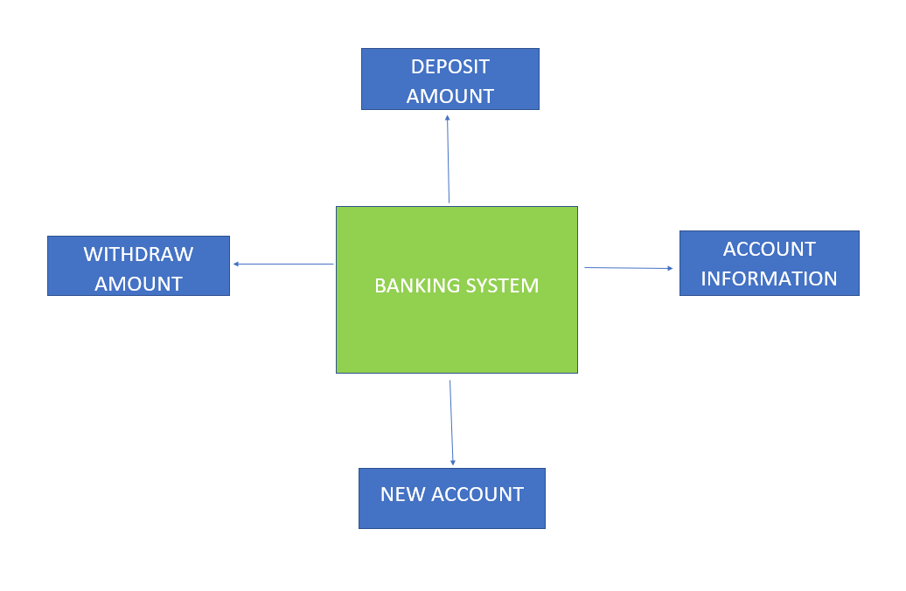

**TEST PLAN**

**4.1 High Level**

|  |  |  |  |  |
| --- | --- | --- | --- | --- |
| ID | Description | Expected I/P | Expected O/P | Actual O/P |
| HLR1 | User is able to open an account | First Name: Abc, Last Name: XYZ, Initial Balance: XXXX00 | Account has been created successfully | Account has been created successfully |
| HLR2 | User is able to deposit money | Enter money you want to deposit : 1000 | The new balance for account X is 2000 | The new balance for account X is 2000 |
| HLR3 | User is able to withdraw money | Enter money you want to deposit : 1000 | The new balance for account X is 1000 | The new balance for account X is 1000 |
| HLR3 | User is able to withdraw money | Enter money you want to withdraw : 2000 | You do not have enough balance in this account | You do not have enough balance in this account |

**4.2 Low Level**

|  |  |  |  |  |
| --- | --- | --- | --- | --- |
| ID | Description | Expected I/P | Expected O/P | Actual O/P |
| LLR1 | User is able to see account details | Enter Account number: 1 | Account Holder’s name: XYZ, Account number: 1 , Available balance: XXXX00 | Account Holder’s name: XYZ, Account number: 1 , Available balance: XXXX00 |
| LLR2 | User is able to see balance | Enter Choice: 3, Enter Account number: 1 | Balance: 3000 | Balance: 3000 |